Practical steps for decreasing of drifter network cost
and increasing of buoy's data quality

Sergey Motyzhev – Marlin-Yug Ltd Venture, Ukraine
E-mail: marlin@stel.sebastopol.ua
Elizabeth Horton – Naval Oceanographic Office, USA
E-mail: hortone@navo.navy.mil

According to the DBCP Implementation Strategy [1], it should be created and maintained the homogeneous network of buoys with a 500*500 km resolution. The main tool for this network should be the low-cost SVP-B drifter and its modifications. The economical compromise, when the price of this network should be available for users and beneficial for manufacturers, is one of the important problems. Marlin together with Navoceano had made some efforts for the solution of this problem. The job was being continued from 1999 to 2001. The general notion of this job is that the following components of problem: scientific, technical, manufacturing, deployment and informational ones are important together for successful operation of buoy network.

There were three main directions, where the cooperation of both participants was being developed:
- Decreasing of data cost.
- Increasing of buoy lifetime.
- Increasing of data quality.
It can be seen from Figure 1, that data cost, attributed for one buoy in operation during the one year, includes the following components: price of buoy manufacturing, delivery of buoy to user, storage of buoy at the user's warehouse, deployment of buoy and payment for Argos. The presented components of Marlin SVP-B cost (for one year) in 1999 had the mean real values after the air deployment of buoy in Indian Ocean by the Navoceano C-130 aircraft.
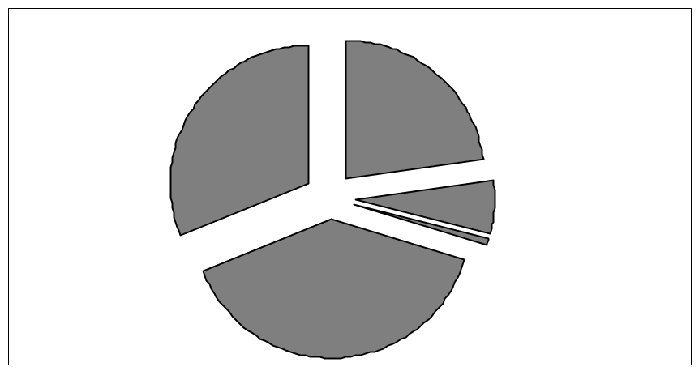
Fig1. Status of data cost in 1999 (for 1 year of buoy in operation)
Storage
$100 (2%)
Deployment
$100-10000
Argos
$4000 (51%)
TOTAL $7800 (100%)

SVP-B buoy
$2900 (37%)

Delivery
$800 (10%)
Of course, the data cost values have the approximate nature, however, they allow to estimate the general scheme of expenditures and separately - the contribution of each component. The cost of buoy deployment is most difficult for estimation, because it depends of many factors, for example: area of deployment, removal from usual ship lines, availability to the passing ships, etc. Therefore the cost of buoy deployment wasn't included into the total cost of drifter operation in situ during one year. Simultaneously it is necessary to mark that deployment of drifters by the Navoceano C-130 aircraft became the most effective way for providing this procedure, especially for areas distant off the regular ship lines. From time to time this airplane provides the round-the-world trip for deployment of buoys in World Ocean.

According to the Figure 1 the total cost of buoy in operation during one year (without the cost of deployment) may be estimated by the following way:
- Cost of buoy - $2900 (37%).
- Cost of buoy delivery from manufacturer to user - $800 (10%).
- Cost of mean duration of buoy storage at warehouse of user - $100 (2%).
- Cost of data transfer via Argos during the one year - $4000 (51%).

Thus, the total cost of one buoy manufacturing, storage, deployment and operation during one year was $7800, as for the 1999. The different ways were necessary for decreasing of fees for each component of total cost. The some work was done by Marlin together with Navoceano from 1999 to 2001 for achievement of this purpose. The main concept of Marlin is that the drifting buoy should have the integrated design, when the mechanical and electronic parts of drifter provide the optimal configuration of buoy in a whole. As result, the decreasing of buoy's cost, increasing of reliability and lifetime is achieved.

Marlin SVP-B drifter of 2-nd generation was created in 1999. The study of buoy parameters was being conducted in the Western Pacific Ocean, the Atlantic Ocean, the Indian Ocean and the Black Sea. Navoceano C-130 aircraft has deployed all the buoys (without the Black Sea buoys). The following parameters of buoy were being investigated:
- Sea Surface Temperature (SST) sensor.
- Battery Voltage (BV) sensor.
- Submergence (Subm) sensor.
- Barometric Pressure (BP) sensor.
- Communication with satellite.
- Location via satellite.
- Compact packing of buoy possibilities.
- Availability for the air deployment.

The data for investigation was being received via ADS distribution system (Naval Oceanographic Office, USA), Drifter distribution system (Department of Oceanography, Naval Postgraduate School, USA) and QC system (http://www.meteo.shom.fr/qctools). The results of investigations in 1999-2000 were presented during the DBCP Workshop in Victoria, Canada, 2000 [2]. It was demonstrated that SST and BV sensors hadn't any problems. The cumulative total error for SST, provided via QC system, didn't exceed 0.6°C. Snbm sensor had the explicable failure due to the used connector between contacts of submergence and main electronic board. The problem of connector was the failure after 5-7 months of buoy in operation according to the oxidation of contacts. This defect was experimentally verified in laboratory.

One of the purposes of job was the creation and testing of low-cost BP channel. Obviously, this channel should have the lifetime same with buoy in whole and full error inside the limits of ± 1 hPa. The typical solution before was that some standard digital sensor with high accuracy and resolution was used together with standard barometric port. This design had a large cost and it didn't provide the appreciable reliability for many cases. Also, the cost of this design was in conflict with coarse accuracy limits for SVP-B's BP.

Thus, goal of cooperation was the creation and testing of low-cost BP channel, by means of the using the some standard low-cost pressure sensor and Marlin electronics. The following components of this channel were investigated:
- Configuration of barometric port.
- Plastic and metallic membranes.
- Optimal magnitude of baroport's back volume and optimal ratio between the volumes before and after membrane.
- Self-cleaning of membranes by pressed air during the submergence cycles.
- Pressure sensors of the different companies (parameters, cost and accessibility).
- Optimal ways of electronics creation (components, cost, power consumption, etc.).
- Of course, all the disposable documents regarding to this matter were being studied.

The low-cost Motorola pressure sensor was used for the Marlin SVP-B of 2-nd generation. This sensor had only one defect: – hysteresis after the influence of negative temperatures. For elimination of this defect the buoy's BP sensor was equipped with the automatic heating system for providing the necessary accuracy. The heating procedure was intended for removal of possible error of BP data after the influence of negative temperatures during the storage or transportation. Heating system was automatically being switched on after a drifter's activation and after impact of water. After deployment the buoy is similar to passive hydrostat and there isn't of BP hysteresis problem, when buoy is in water.

The long-time testing of buoys with this BP channel was done in Indian Ocean and North Atlantic after the deployments in 1999 by Navo C-130. The results were optimistic ones. The appearance of 'too scattered' BP data after the 4-5 months for some buoys wasn't a problem of chosen sensor [2]. This temporal failure was a result of engineer mistake. The matter of this mistake was the closing of flexible tube between baroport and BP sensor by the compressed rubber pad. After the 7-8 months the tubes had been again opened and data of buoys were repeatedly put on GTS. The next block of Marlin SVP-Bs, produced and deployed in 2000, hadn't this defect.

The testing in situ of the developed low-cost BP channel via QC system indicated that cumulative mean error of buoys didn't exceed ±1 гПа during the full lifetime of buoy in operation. The acceptable demonstration of BP channel reliability is the registration of Ocean Cyclone Charly in the Indian Ocean by the Marlin SVP-B ID53513/WMO26216 after the 442 days in operation (Figure 2).
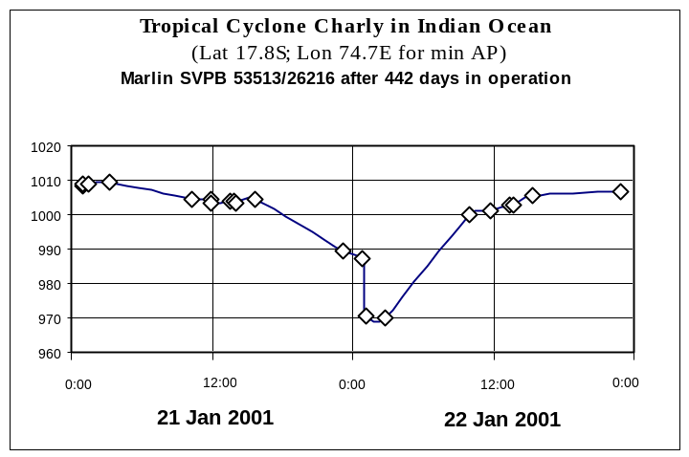
Fig.2. Registration of the Tropical Cyclone Charly
Thus, the low-cost BP channel on the base of Motorola pressure sensor has demonstrated the acceptable operation according to the requests to SVP-B buoy. Simultaneously, it became clear the problems of this BP channel. They were the followings:
- Limited number of On/Off cycles for buoy before its deployment.
- Possible systematic shift of BP data inside the limits of +/-1 hPa.

These defects became the basis for creation of new low-cost BP channel, but without the problems provided above. This job was begun in 2000. The Siemens KPY53 pressure sensor was chosen for new Marlin BP channel. This sensor has the following advantages:
- Greater sensitivity.
- High linearity.
- Very low pressure and temperature hysteresis.
- High load cycle stability.
- Built in temperature sensor.

New Marlin BP channel on the base of KPY53 provides the operation without problems, which ones had the BP channel on the basis of Motorola sensor. This channel is precision, programmable, high dynamic range delta-sigma converter, capable for operation with high resolution and accuracy. It includes the completed on-board calibration with temperature compensation, what provides the necessary offset and limited external system errors in the wide temperature range.

CLS Argos persistently offers to use the Argos-2 extended band-wide for decreasing of load in a system, increasing of link reliability and improvement of the locations quality. The 10% discount for Argos payment was proposed in 1999 for the inducing of users to employ the new channels outside of Argos-1 frequency. Unfortunately this discount was abolished in 2001. However, advantage of new frequencies is obvious for all and it should be utilized in buoys of new generations.

The division of buoy into two parts provides the optimal packaging of buoys in shipping crates. The total volume of two packaged buoys is less than packaged volume for one buoy in the one shipping crate. As result, the total economy of expenditures for air transportation of buoys is more than 30%, and the total space economy when storage of buoys at warehouse is more than 50%. Studies of buoys in situ have shown that the drogues remain properly attached after deployment during lifetime more than 600 days of buoy in operation.

The air deployments of buoys provide some advantages in comparison with ship deployments. They are the followings:
- Fast restoration of network density.
- Deployment when complex weather conditions.
- Global coverage.
- Smaller cost for many cases of deployments.
Navoceano has successfully conducted in 1999 and 2000 operational tests and evaluation of some 12 Marlin SVP-B drifters from C-130 aircraft under specific circumstances including a qualified Navoceano representative onboard during any drops. Test drops were conducted in the Western Pacific Ocean (5 drifters), the Atlantic Ocean (2), and the Indian Ocean (5). As a result of this testing Navoceano consider that Marlin SVP-B drifters are safe to deploy by C-130 aircraft in accordance with their regulations. They are well balanced and achieve normal operation after air deployment.

The buoy lifetime is another relevant parameter for the increasing of drifter network efficiency. Really, than longer the buoy will be in operation, than less the share of initial expenditures in the cost referred to one day of buoy in operation. The buoy lifetime depends of the following components:
- Kind and number of used batteries.
- Using the battery up to the full empty.
- Minimum consumption by buoy's electronics.
- Data format.

The theoretical lifetime of different generations of Marlin SVP-B is presented at Figure 3.
The real lifetime for buoy of 2-nd generation may be demonstrated for Marlin SVP-B ID26221/WMO53512. This buoy was deployed November 9, 1999 by C-130 aircraft in the central part of Indian Ocean. It was in operation during the 664 days with correct data of all sensors. Buoy was switched off automatically, when the level of battery voltage became equal to 8 V.
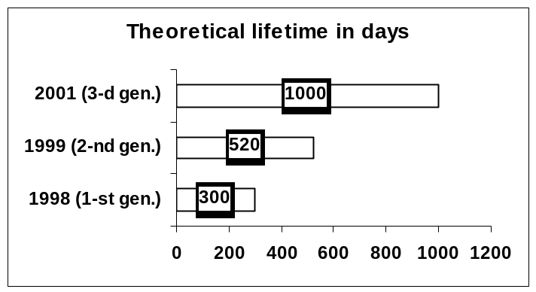
Fig.3. Theoretical lifetime of Marlin SVP-Bs
For the data formats unification the DBCP-M1 format of buoy's message was recommended in 2000 for data transfer via Argos. This format had some advantages as for the other formats and could be useful as for meteorologists, as for oceanographers. In 2000 the new 28-bit ID was also proposed by Argos, because the number of buoys in operation is becoming many more than before. The direct utilization of both novelties didn't provide the optimal data format for SVP-B drifter, because the exuberant data should be transmitted, and it is an additional load as for Argos system, as for buoy's battery.

As a result of long discussing, the new meteorological format - DBCP-M2 (http://www.jcommops.org/dbcp/fmt-dbcp-m2.html) was developed. This format was recommended for different buoys including the SVP-B drifters. Basic advantages of format is that it gives of approximately 12 % economies of battery energy, provides the decreasing of load for Argos and doesn't require the updating of software for data processing and distribution via GTS. Besides, the format provides the unification of full-completed cycle for the transfer, reception, processing and distribution of data, when using of both IDs (20-bit and 28-bit).

All the above was taken into account when creation the Marlin SVP-B of 3-d generation in 2001. There were the following reasons for creation of this buoy:
- Operation of buoy together with Argos-3 receiver and GPS.
- Study of meteorological processes with fast variability.
- Increasing of buoy's data quality.
- Increasing of buoy's lifetime.
- Data stability, when impulse and temperature influence on buoy.
- New possibilities and areas of applications.

The main novelty of new Marlin SVP-B is the new electronics. This electronics (for standard SVP-B buoy) contains two new Marlin boards:
- MT102A – Argos Platform Transmitter Terminal with software of own controller created to provide the economic operation with the PTSV-D sensors board.
- PTSV-D - BP, SST, SubM and VBat sensors with software of own controller created to provide the economic operation with the MT102A PTT.
The Technical parameters of electronic boards are presented below in Tables 1 and 2:

Table 1. Technical parameters of PTT MT102A board
MT102A | General  PTT MT102A is intended for acquisition, processing and transfer of data from self-powered measuring platforms. PTT provides operation in a low-power mode for increasing of platforms lifetime. Built-in controller and standard input interface RS-232 provides for MT102A the flexibility and cost effective solution for many applied goals.  PTT Parts  PTT MT102A is a high-integrated one-board system. It contains:  - Transmitter with termocompensated quartz oscillator.  - DC-DC voltage converter.  - High-performance RISC-microcontroller.  - Application software.  Hardware Features  - Operation range: minus 30 to +60°C.  - Carrier frequency: 401.640 MHz (S6 Argos channel). It may be provided any channel inside the Argos-2 bandwidth between the 401.629 and 401.681 MHz.  - Voltage range: +7 to +16 VDC.  - Repetition period: 5 s and more.  - Power (current) requirements: transmit mode < 0.75 A; sleep mode < 1.0mA.  - Transmitting power: 1.2 ± 0.2 W (50 Ohm).  - Interface: RS-232.  Sizes and Weight  - Sizes: 110 × 80 × 20 mm.  - Weight: 80 g.

PTT MT MT102A use the carry frequency outside of the Argos-1 bandwidth. This particularity of terminal provides the decreasing of load for main Argos frequency, the increasing the number of contacts between buoy and satellite and also quality of locations. Thus, the resolution of drifter networks will be better.

Table 2. Technical parameters of PTSV-D board
PTSV-D | General  PTSV-D is intended for measurement of air pressure, water temperature, submergence and power supply voltage for the self-powered systems of an environment and production processes monitoring (SVP-B drifters; meteorological stations, wave recorders; tide gauges etc.). Built-in controller and standard interface RS-232 provides for PTSV-D the flexibility and cost effective solution for the many applied goals.  PTSV-D Parts  PTSV-D is a high-integrated one-board system. It contains:  - BP sensor.  - SST sensor.  - BV sensor.  - Submergence counter.  - High-performance RISC-microcontroller.  - Application software.  Remark: The range, accuracy and resolution of sensors, adapted to DBCP-M2 data format, are presented in Table 3  Hardware Features  - Operation range: minus 30 to +50°C.  - Voltage range: +6 to +15 VDC.  - Power supply current (in operation) < 7 mA.  - Interface: RS-232.  - Data rate: 1 Hz.  - Pressure overload: 10000 hPa.  - Long-term stability.  - Stability to vibration and impulse load.  - Metrological characteristics of sensors, adopted under the SVP-B drifter requests.  Software Features  ▪ High-performance on board self calibration  ▪ Quick re-configuration  ▪ Output format: DBCP-M2 or any other  ▪ Non-volatile memory for 16 last measurements  Sizes and Weight  - Sizes: 80 × 80 × 30 mm  - Weight: 50 g

The optimal configuration of two-boards electronics and using of new more integrated electronic components has allowed the decreasing of power consumption and increasing of buoy lifetime. The theoretical lifetime of buoy may be up to 1000 days in operation. Also, the reduced number of electronic components and new technology of automatic calibration of sensors has decreased the cost of buoy in whole.

Table 3. Sensors parameters, adapted under DBCP-M2 data format
Parameter | Range | Resolution | Accuracy
Barometric pressure, hPa | 850 to 1054.7 | 0.1 | ±0.5
Water temperature, °C | minus 5 to +35.88 | 0.08 | ±0.2
Supply voltage, V | 7 to 14 | 1.0 | ±0.5
Submergence Count, % | 0 to 100 | 100/63 | ±0.06

Three main conclusions may be determined as a result of Marlin and Navoceano cooperation: technical, financial and scientific one. The first conclusion is that the new buoy, with technical parameters provided above, was created and it is the next step for realization of DBCP Implementation Strategy with purpose of standard observations. The second conclusion is that approximately 9% decreasing of data cost was achieved, as it is presented at Figure 4. The decreasing of full cost was provided by the new buoy's price and decreasing of fees for shipment and storage. The parts of cost, as for the Argos and deployment, continue be as prior one. Thus, the ratio of cost's parts in percents became another and the part of payment for Argos and deployment became more than before.
Fig.4. Status of cost in 2001 in comparison with 1999
Delivery
$550 (8%)
Storage
$50 (1%)
Argos
$4000 (56%)
TOTAL $7100 (-9%)
Deployment
$100-10000
SVP-B buoy
$2500 (35%)
Two-processor electronics of buoy extends the area of application of new buoy, particularly for scientific purposes. Study of hydrometeorological processes (for example: ocean typhoons and cyclones) with variable duty cycle of BP samples, assessing of wave parameters, increasing of flexibility of buoy self-control (automatic on/off possibilities, according to the outside parameters), additional sensors, etc may be provided by this buoy.

References
1. Global Drifting Buoy Observations – A DBCP Implementation Strategy. DBCP Technical Document Series, No.15. World Meteorological Organization, Geneva, 1999.

2. S. Motyzhev, E. Horton. Marlin SVP-B drifters evaluation after one-year operation in situ. Developments in buoy technology, communications and data applications. – UNESCO DВCP Technical Document Series, No.19–2001-P.11-16.

